Sire: 038/ 039
Latitude: 55.31892
Longtitude: -162.57654
Dates Surveyed: 8/4 - 8/6/2025
Anadromous fish species captured: Coho Salmon
Notes: Sampled on the ground on 8/5/2025. Proposed crossings 038 and 039 are in proximity and are hydrologically connected. Water is flowing out of a pond through a small, defined stream channel and into a wetland complex. Captured Coho salmon, ninespine stickleback, and threespine stickleback.

Photographs

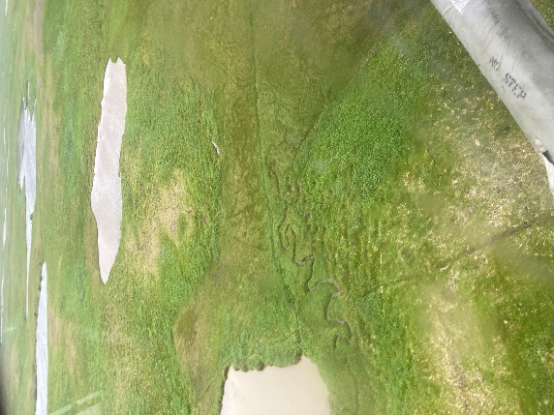 | 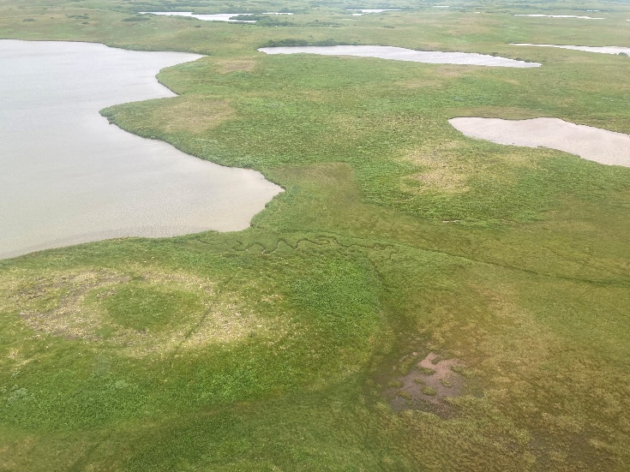
Photo looking southeast, stream flowing from left to right. | Photo looking southeast, stream flowing from left to right.
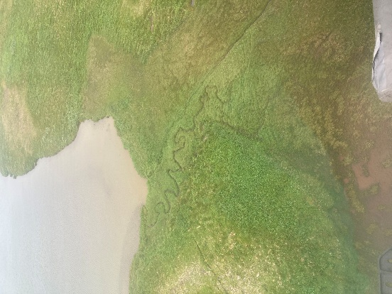  Photo looking east, stream flowing from left to right. | 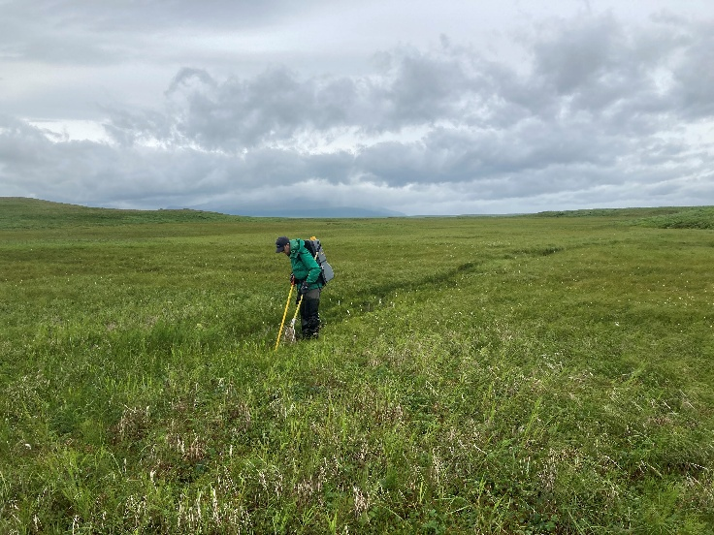  Electrofishing the pond outlet stream channel, looking south. Stream flowing from left to right.

Stream Crossing ID: 038 and 039 Continued

Photographs

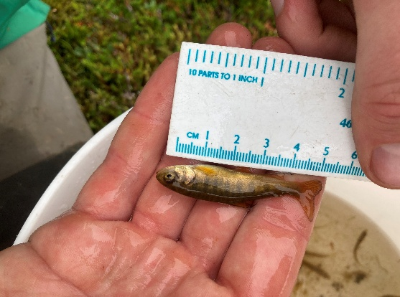 | 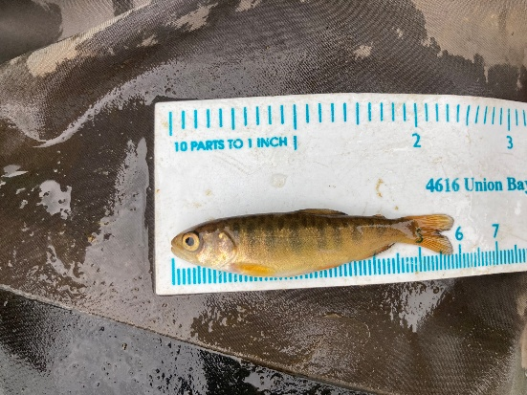
Juvenile Coho Salmon captured at Stream Crossings 038/039. | Juvenile Coho Salmon captured at Stream Crossings 038/039.

